I want to create a new version of my room thermostat, and this time I want to order an assembled PCBA at JLCPCB. Eventually I also want to add a USB-C connector, power supply and ESP32 to the board, but to try out if my KiCad skills are sufficient, I first created a very simple board, which only consists of the redlined area of the schematic below:

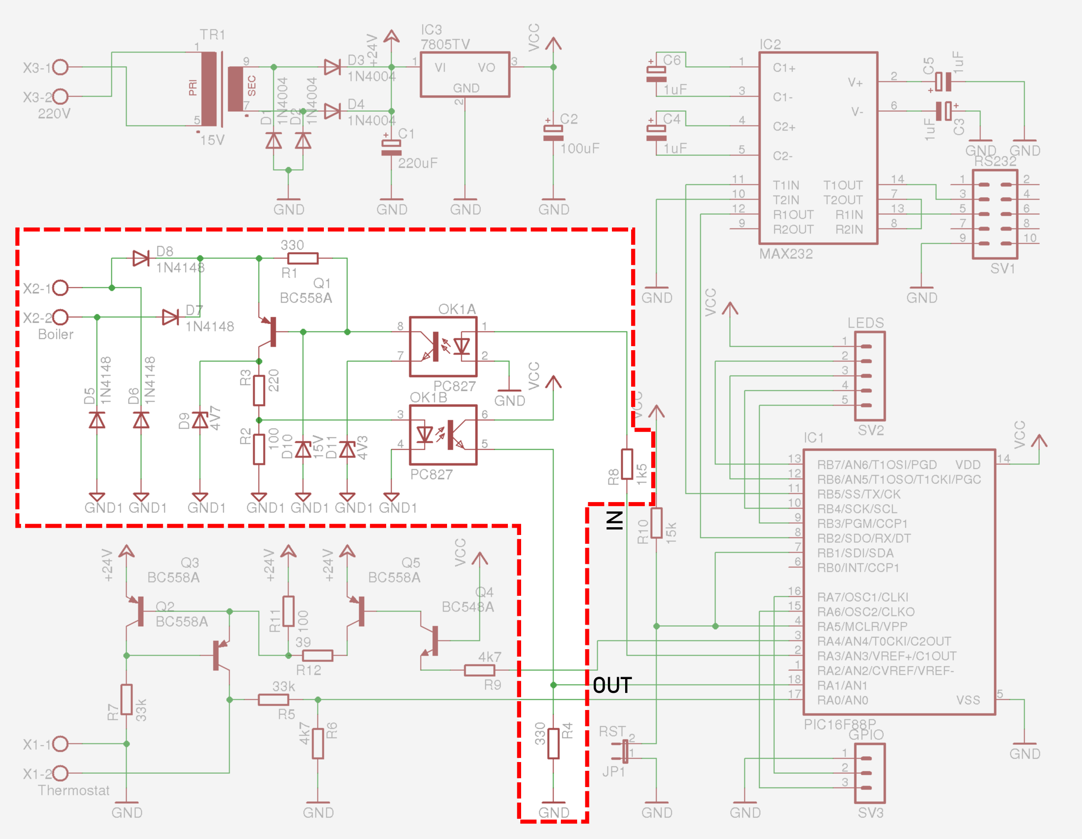

I copied this schematic from: [otgw.tclcode.com/schematic](https://otgw.tclcode.com/schematic.html#schematic)

I needed to transfer the components list:

* Conrad numbers are provided, where I need JLCPCB part numbers
* I need to substitute through-hole components by surface mounted devices

The original parts list is (only the relevant parts):

| **Reference** | **Description** | **Value** | **Conrad** | **Detailed description from Conrad** (Dutch) |
| --- | --- | --- | --- | --- |
| **OK1** | Dual opto-coupler | PC827 | [140235-89](https://www.conrad.nl/zoeken?search=140235-89) | Broadcom Optocoupler fototransistor ACPL-827-000E DIP-8 Transistor DC |
| **Q1** | PNP Transistor | BC558A | [1262971-89](https://www.conrad.nl/zoeken?search=1262971-89) | Diotec Transistor (BJT) - discreet BC558A TO-92 PNP |
| **D5**, **D6**, **D7**, **D8** | Diode | 1N4148 | [162280-89](https://www.conrad.nl/zoeken?search=162280-89) | Diotec Ultrasnelle Si-diode 1N4148 SOD-27 75 V 150 mA |
| **D9** | Zener Diode | 4V7 | [180084-89](https://www.conrad.nl/zoeken?search=180084-89) | Diotec Zenerdiode ZPD4.7 Behuizingssoort (halfgeleider) DO-35 Zenerspanning 4.7 V Vermogen (max.) P(TOT) 506 mW |
| **D10** | Zener Diode | 15V | [180203-89](https://www.conrad.nl/zoeken?search=180203-89) | Diotec Zenerdiode ZPD15 Behuizingssoort (halfgeleider) DO-35 Zenerspanning 15 V Vermogen (max.) P(TOT) 518 mW |
| **D11** | Zener Diode | 4V3 | [180076-89](https://www.conrad.nl/zoeken?search=180076-89) | Diotec Zenerdiode ZPD4.3 Behuizingssoort (halfgeleider) DO-35 Zenerspanning 4.3 V Vermogen (max.) P(TOT) 505 mW |
| **R2** | 1/4 Watt 5% Resistor | 100 | [1417639-89](https://www.conrad.nl/zoeken?search=1417639-89) | Yageo CFR25J100RH CFR-25JT-52-100R Koolfilmweerstand 100 Ω Axiaal bedraad 0207 0.25 W 5 % 1 stuk(s) |
| **R3** | 1/4 Watt 5% Resistor | 220 | [1417693-89](https://www.conrad.nl/zoeken?search=1417693-89) | Yageo CFR25J220RH CFR-25JT-52-220R Koolfilmweerstand 220 Ω Axiaal bedraad 0207 0.25 W 5 % 1 stuk(s) |
| **R1**, **R4** | 1/4 Watt 5% Resistor | 330 | [1417730-89](https://www.conrad.nl/zoeken?search=1417730-89) | Yageo CFR25J330RH CFR-25JT-52-330R Koolfilmweerstand 330 Ω Axiaal bedraad 0207 0.25 W 5 % 1 stuk(s) |
| **R8** | 1/4 Watt 5% Resistor | 1k2 | [1417712-89](https://www.conrad.nl/zoeken?search=1417712-89) | Yageo CFR25J1K2H CFR-25JT-52-1K2 Koolfilmweerstand 1.2 kΩ Axiaal bedraad 0207 0.25 W 5 % 1 stuk(s) |

My new schematic looks like this:

I installed a library of JLCPCB components and footprints from <https://github.com/CDFER/JLCPCB-Kicad-Library.git>, but found that some components are missing. I tried to find equivalent SMT components on [https://jlcpcb.com/partdetail](https://jlcpcb.com/partdetail/). Typically, several versions of a component exist, and specifications are slightly different from the original through-hole part.

Starting with D1, D2, D3 and D4 in the new bill of materials, this is the original 1N4448 from the Conrad part:

In JLCPCB, I sorted on available stock and started at the top:

Here is a sample of the datasheet of the Xzt 1N4448W, LCSC# C5805633:

Comparison:

| **Property** |  | **1N4448**  **Conrad** | **1N4448W**  **JLCPCB** | **Suitable** |
| --- | --- | --- | --- | --- |
| Reverse voltage | VR | 75 V | 100 V (?) | OK |
| Repetitive peak reverse voltage | VRRM | 100 V | 75 V | NOK |
| Max. average forward rectified current, R-load | IFAV | 150 mA | ? | ? |
| Repetitive peak forward current | IFRM | 500 mA | ? |  |
| Non-repetitive peak forward current, tp = 1 µs | IFSM | 2000 mA | 2 A | OK |
| Power dissipation | Ptot | 500 mW | 500 mW | OK |

To know if the JLCPCB version is suitable for this application, I would need to reverse-engineer the circuit based on the OpenTherm specification. **What kind of due diligence is common when designating alternative components?**

I assumed the JLCPCB part is suitable.

The part was not in the library, so I modified the values of a generic diode to match the C5805633. **Is that also common, or are there clever ways to obtain the part and footprint?**

As part of this, I had to choose a footprint. JLCPCB specifies an SOD-123 footprint looking like this:

KiCad offers three flavours of SOD-123 footprint:

I more or less randomly opted for the third one since it is specified as SOD-123_... instead of SOD-123F_... **Could I have made a more elaborate decision there?**

Next is D5, the 4.7V Zener diode. The Conrad datasheet (BZX55-C4V7) specifies:

Again, sorting on stock level, I chose the first one with a power dissipation of 500 mW, the ZMM4V7 from Slkor, a.k.a. C707193:

| **Property** |  | **BZX55-C4V7**  **Conrad** | **ZMM4V7**  **JLCPCB** | **Suitable?** |
| --- | --- | --- | --- | --- |
| Continuous forward current | IF | 250 mA | no spec. | ? |
| Non-repetitive peak reverse current | IZSM | 6 A | no spec. | ? |
| Total power dissipation | Ptot | 400..500 mW | 500 mW | Yes |
| Non-repetitive peak reverse power dissipation | PZSM | 30..40 W | no spec. | ? |

I decided that this component is probably unsuitable, so I chose the next in line, the BZT52C4V7S, a.k.a. C5190168. However, according to the datasheet the power dissipation is limited to 200 mW instead of 500 mW, so I moved on to the MM1Z4V7, a.k.a.. C22379458.

| **Property** |  | **BZX55-C4V7**  **Conrad** | **MM1Z4V7 JLCPCB** | **Suitable?** |
| --- | --- | --- | --- | --- |
| Continuous forward current | IF | 250 mA | no spec. | ? |
| Non-repetitive peak reverse current | IZSM | 6 A | no spec. | ? |
| Total power dissipation | Ptot | 400..500 mW | 500 mW | Yes |
| Non-repetitive peak reverse power dissipation | PZSM | 30..40 W | no spec. | ? |

Although it feels like a significant leap of faith since so little is specified, I decided to go for the MM1Z4V7 because the ZMM4V7 has a LL-34 package which looks odd.